STOP NUCLEAR TRAINS THROUGH HIGHBURY & ISLINGTON STATION!
These “nuclear trains” carry highly-radioactive nuclear fuel rods taken out of the nuclear power station at Sizewell in Suffolk. They travel through east and north London on the North London Line and then on right up to the Sellafield nuclear plant in Cumbria where the deadly plutonium and uranium they contain are separated out.
THESE CARGOES ARE DANGEROUS
- These trains continuously emit low-level radiation – and exposure to any increase in radiation means increased risks of cancers.
- As a result of a serious accident or terrorist attack the rod containers could break open, releasing highly-radioactive material that would blow for miles in the wind and kill thousands of people in a built-up area like Islington. Such a disaster would also require mass evacuation.
- The only current use for the plutonium they contain is in nuclear warheads such as those carried on Britain’s nuclear submarines.
- Ask your MP or local Councillor to try to get these trains stopped from going through Islington and anywhere else in London.

JOIN THE CAMPAIGN
Join our campaign by filling-in and returning the slip below to: Nuclear Trains Action Group, 162 Holloway Rd, N7 8DQ; tel. 020-7607 2302, or e-mail: david.lrcnd@cnduk.org.
Web site: www.nonucleartrains.org.uk
-----------------------------------------------------------------------------------
I would like more information about nuclear trains 
I wish to join the Nuclear Trains Action Group 
I would like to donate £……. (Make out cheques to: “NTAG.”)
Name and address/e-mail (write clearly)…………………………………..
………………………………………………………………………............
……………………………………………………………………………….

NUCLEAR DANGER UNDER YOUR FEET!
Trains like the one shown in the photo below regularly go through Highbury & Islington station. These trains carry highly-radioactive cargoes (in white containers like the one shown in the photo), which, in an accident, could release high-level radiation which could kill thousands of people.
NUCLEAR TRAIN ROUTES IN LONDON

To SELLAFIELD From SIZEWELL
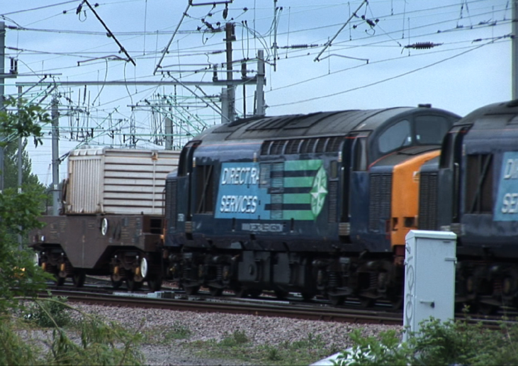

● Wembley Central

Willesden ● ● ● ● ●
Junction Camden Highbury Hackney Stratford
Road & Islington Central

Kensington ●
Olympia
● ● ●
Brixton Peckham Bromley
Rye South

From DUNGENESS

Photo shows a nuclear train pulling a flask across Walthamstow Marshes. (Photo: Jonathan Brind, May 2010.)
Nuclear trains consist of two locomotives drawing one or more containers (“flasks”) of highly-radioactive nuclear fuel rods immersed in water to stop them from heating up and melting down, which they would otherwise do.

