La Kuwe
The Martial Art of Kuwe (the hoe) is a combat technique from the Japanese army, originating on the islands of Okinawa in the Edo Epoch(1600-1868).
The population of the Okinawa islands had always been closer geographically and culturally to China and Taiwan. In the beginning of the Edo times, the Satsuma dynasty was ruling on the islands, and installed several rules, which forbade the use of weapons for non-aristocrats along with high taxes with the hope to subdue the whole region for once. To continue their resistance, the farmes started to use their working tools as weapons, which gave birth to what later, in the end of the 19th century became the Kobudo, literally « famers fighting arts ». Kuwe was not the only tool the farmes tranformed to become a weapon : we can actually find several other martial arts that were derived from agricultural tools : the Nunshaku (Chakos), the Japanese flail; the saïs, a tipe of small hand pitch forks which was used to gather the haystacks; the staff, or Bô, are some of this range of ingenious adaptations. Here we are talking about things natural in an agricultural society, extremly wide spread and totally accepted. There is not a single Kata (form) for the Kuwe, opposed to other martial arts weaponery.

Inspite the Kuwe being know, under different names, to agriculturalist of the whole world, its use as a weapon of self defense is only known in Asia and still here not very wide spread, by its very nature. Currently it is found in a folkloric context and maybe sometimes in Martila Arts demonstrations without referring at all to peasant struggles.
On could argue that that has to do with a general moving away from fighting techniques, which is generaly connected to a preference to go the legal, political or medial way, and that, if arms are used, the choice is weapons that request less maestry, like a machete, or firearms, which are produced in great quantity for that specific use.
However we do see the reappearance of the Kuwe used collectivly, in an aesthetic way.
There are groups that practice Kuwataka and turn it into demonstrations supporting a peasantry that is autonomous and free of choice. We could for exmple observe them in Switzerland on the International day of peasant struggles, on the 17th of april 2011, and also in Brussels in june 2014 around the trial about a ripping out of GMO potatoes.
Without entering into a spiral of violence, this tools and also other agricultural tools(pitch fork, sickle, tractor) immediately install a relationship of actual strength facing authorities, who then back off and give passage to those demonstrations «with the pitch forks in the hands». Are they fearing the peasants, who traditionaly haven´t hesitated to use physical force and intimidation to make their rights and demands taken into account (Rennes 2006, Kulon Progo, demonstration ocupation, The movement of people without land in Brasil)?
To read this fear in the eyes of those who normally impose on us their rules and violence reminds us that, beneath their uniforms, there are hidden just plain human beings, far from being all mighty if one gives them the concrete means to stop going along and get out of their conventional organisation.
What makes the difference, in the end, to our medival occidental peasants, is that our fighting arts have lost their actuality (except for some laypersons and explorers), whilest the Japanese didnt only conserve them but also cultuvated them in a cultural ambit.

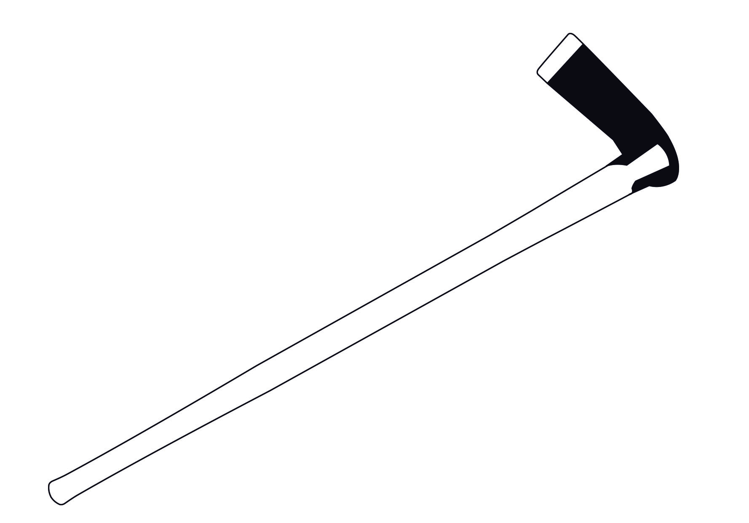
The Kuwe aswers to a defensive need by its nature. Its a big staff ornated with a heavy pieace of metal ideal for hitting but also for executing a defense. The specific of the Kuwe, opposed to the Bô (or staff), is exactly this hybrid nature. The execution of techniques special to the staff has become quite available: actually, if its absence of a blade (ejiri) might make it appear less dangerous then the other, thats because one forgets the weights of the kuwaba: by giving counterweight it allows extremly fast movements making it possible to hit with the blade. The other part of the handle (egashira) makes the Kuwe similar to the staff, if a little shorter, which again allows faster moves, along with withdrawals and avances. The kuwaba can be used to project the force of the ground on the adversairy, even to the extent of grapping a limp.

Resources :
La Nouvelle Histoire du Japon, Pierre François Souyri, Edition Perrin, 2010.
Kobudo d’Okinawa, Kenyu Chinen, Sedirep, 1985.

