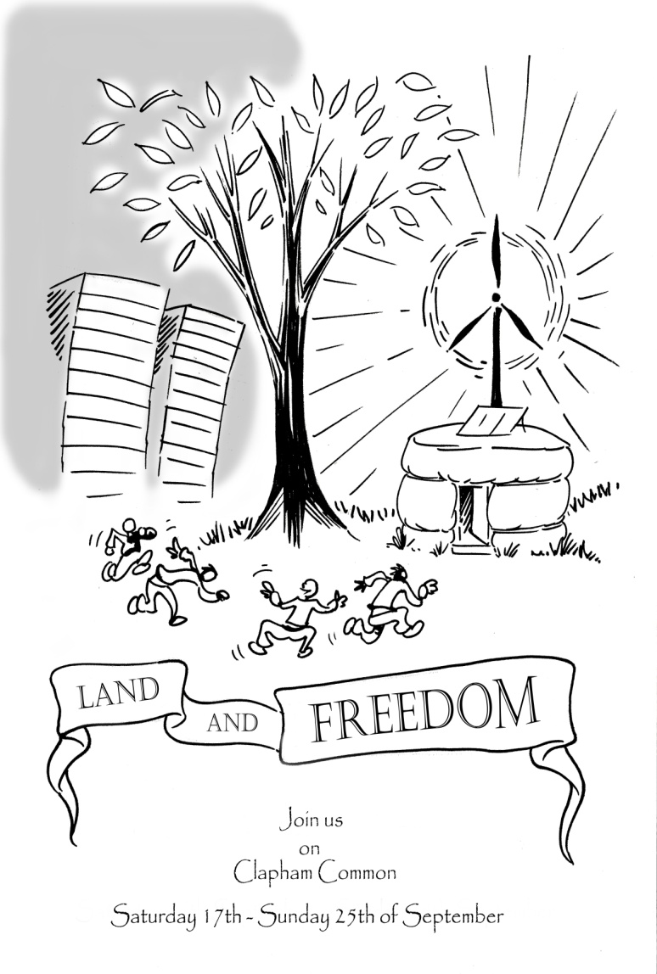
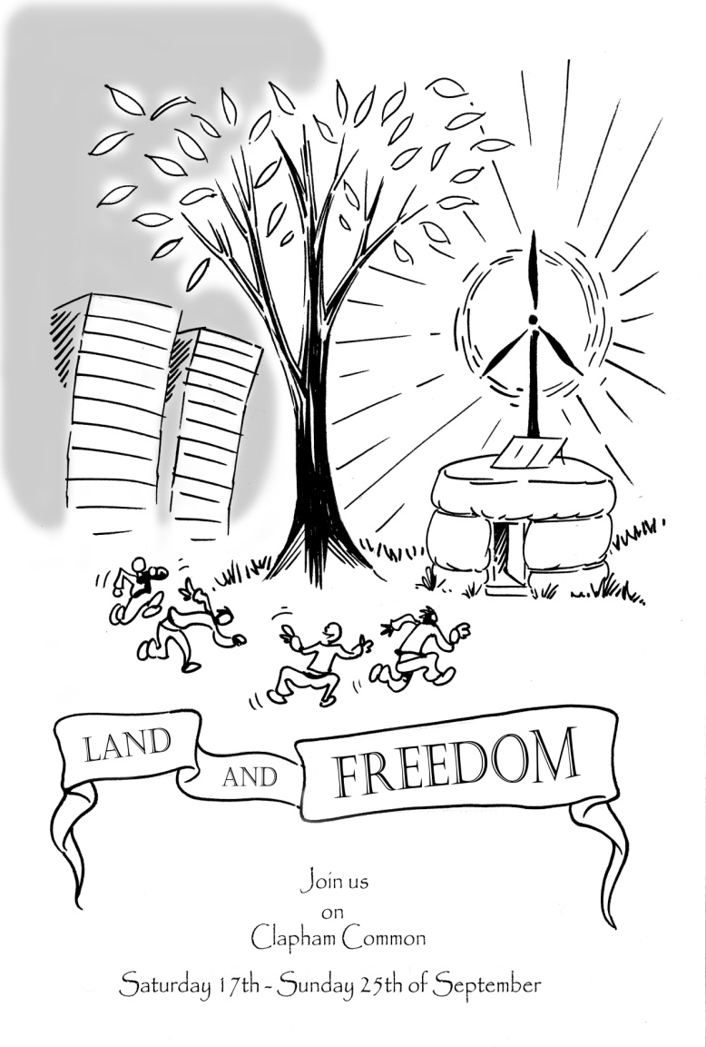

Reclaim the commons!
Lets celebrate the people’s right to the commons, their local and global movements to free the world (and our minds) from the enclosures that keep the earth from being what it should be: a COMMON treasury for all
Join us on Clapham Common from the 17th to 25th September 2011, for debate, demonstration and community building; to share hope and inspiration and work together towards a true global solidarity in spirit AND action.
Things to bring:
Warm clothing, waterproofs, tent, sleeping bag, a mug, bowl + spoon.
Where do we meet:
We will be meeting at the Bandstand on Clapham Common from 11:59 a.m on Saturday 17th September.
Contact Details:
For more info about the camp, please contact: landandfreedomcamp@aktivix.org
or contact: 07963 475 195.
www.landandfreedom.squat.net

Reclaim the commons!
Lets celebrate the people’s right to the commons, their local and global movements to free the world (and our minds) from the enclosures that keep the earth from being what it should be: a COMMON treasury for all
Join us on Clapham Common from the 17th to 25th September 2011, for debate, demonstration and community building; to share hope and inspiration and work together towards a true global solidarity in spirit AND action.
Things to bring:
Warm clothing, waterproofs, tent, sleeping bag, a mug, bowl + spoon.
Where do we meet:
We will be meeting at the Bandstand on Clapham Common from 11:59 a.m on Saturday 17th September.
Contact Details:
For more info about the camp, please contact: landandfreedomcamp@aktivix.org
or contact: 07963 475 195.
www.landandfreedom.squat.net

Reclaim the commons!
Lets celebrate the people’s right to the commons, their local and global movements to free the world (and our minds) from the enclosures that keep the earth from being what it should be: a COMMON treasury for all
Join us on Clapham Common from the 17th to 25th September 2011, for debate, demonstration and community building; to share hope and inspiration and work together towards a true global solidarity in spirit AND action.
Things to bring:
Warm clothing, waterproofs, tent, sleeping bag, a mug, bowl + spoon.
Where do we meet:
We will be meeting at the Bandstand on Clapham Common from 11:59 a.m on Saturday 17th September.
Contact Details:
For more info about the camp, please contact: landandfreedomcamp@aktivix.org
or contact: 07963 475 195.
www.landandfreedom.squat.net

Reclaim the commons!
Lets celebrate the people’s right to the commons, their local and global movements to free the world (and our minds) from the enclosures that keep the earth from being what it should be: a COMMON treasury for all
Join us on Clapham Common from the 17th to 25th September 2011, for debate, demonstration and community building; to share hope and inspiration and work together towards a true global solidarity in spirit AND action.
Things to bring:
Warm clothing, waterproofs, tent, sleeping bag, a mug, bowl + spoon.
Where do we meet:
We will be meeting at the Bandstand on Clapham Common from 11:59 a.m on Saturday 17th September.
Contact Details:
For more info about the camp, please contact: landandfreedomcamp@aktivix.org
or contact: 07963 475 195.
www.landandfreedom.squat.net

